**DYNAMIC ROUTING USING OSPF (SINGLE AREA) PROTOCOL WITH VLSM**

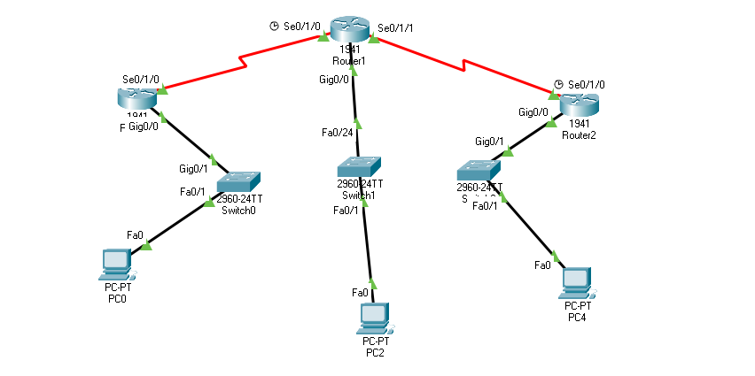

**Router 1 Basic Configuration**

Router>enable

Router#conf terminal

Router(config)#

Router(config)#interface g0/0

Router(config-if)#ip address 200.0.0.65 255.255.255.224

Router(config-if)#no shutdown

Router(config-if)#exit

Router(config)#

Router(config)#interface serial 0/1/0

Router(config-if)#ip address 200.0.0.113 255.255.255.252

Router(config-if)#no shutdown

Router(config-if)#clock rate 64000

Router(config-if)#no shutdown

Router(config-if)# ^Z

Router#write

Building configuration...[OK]

**Router 1 OSPF (Single Area) Protocol Configuration**

Router(config)#router ospf 10

Router(config-router)#network 200.0.0.64 0.0.0.31 area 0

Router(config-router)#network 200.0.0.112 0.0.0.3 area 0

Router(config-router)#^Z

Router#write

Building configuration...

[OK]



**Router 2 Basic Configuration**

Router>enable

Router#conf terminal

Router(config)#

Router(config)#interface g0/0

Router(config-if)#ip address 200.0.0.1 255.255.255.192

Router(config-if)#no shutdown

Router(config-if)#exit

Router(config)#

Router(config)#interface serial 0/1/0

Router(config-if)#ip address 200.0.0.114 255.255.255.252

Router(config-if)#no shutdown

Router(config-if)#exit

Router(config)#

Router(config)#interface s0/1/1

Router(config-if)#ip address 200.0.0.117 255.255.255.252

Router(config-if)#no shutdown

Router(config-if)#exit

Router(config)#^Z

Router#write

Building configuration... [OK]

**Router 2 OSPF (Single Area) Protocol Configuration**

Router(config)#router ospf 10

Router(config-router)#network 200.0.0.0 0.0.0.63 area 0

Router(config-router)#network 200.0.0.112 0.0.0.3 area 0

Router(config-router)#network 200.0.0.116 0.0.0.3 area 0

Router(config-router)#^Z

Router#write

Building configuration... [OK]



**Router 3 Basic Configuration**

Router>enable

Router#conf terminal

Router(config)#interface g0/0

Router(config-if)#ip address 200.0.0.97 255.255.255.240

Router(config-if)#no shutdown

Router(config-if)#exit

Router(config)#

Router(config)#interface s0/1/0

Router(config-if)#ip address 200.0.0.118 255.255.255.252

Router(config-if)#no shutdown

Router(config-if)# ^Z

Router#write

Building configuration...[OK]

**Router 3 OSPF (Single Area) Protocol Configuration**

Router>enable

Router#conf terminal

Router(config)#router ospf 10

Router(config-router)#network 200.0.0.96 0.0.0.15 area 0

Router(config-router)#network 200.0.0.116 0.0.0.3 area 0

Router(config-router)#^Z

Router#write

Building configuration...

[OK]